**Lab1: Suppose you are a teacher, and you want to analyze the exam scores of your students in a particular subject. You have recorded the scores of your students for a recent exam, and you want to represent this data using a Pandas Series.**

**Input:**

**students = ['Alice', 'Bob', 'Charlie', 'David', 'Eve', 'Frank', 'Grace', 'Hannah', 'Ivy', 'Jack']**

**exam_scores = [92, 88, 76, 94, 82, 90, 85, 89, 78, 91]**

**Code:**

**import pandas as pd**

**# Input data**

**students = ['Alice', 'Bob', 'Charlie', 'David', 'Eve', 'Frank', 'Grace', 'Hannah', 'Ivy', 'Jack']**

**exam_scores = [92, 88, 76, 94, 82, 90, 85, 89, 78, 91]**

**# Create a Pandas Series**

**scores_series = pd.Series(data=exam_scores, index=students)**

**# Output the Pandas Series**

**print(scores_series)**

**Output:**

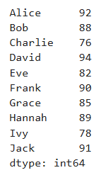

**Lab2: Suppose you want to track and analyze your household expenses for a month. You have recorded the expenses for various categories, such as groceries, utilities, rent, transportation, and entertainment. You can represent this expense data using a Pandas Series.**

**Input:**

**# Expense categories**

**categories = ['Groceries', 'Utilities', 'Rent', 'Transportation', 'Entertainment']**

**# Monthly expense data (example data in USD)**

**expenses = [500, 200, 1200, 300, 150]**

**Code:**

**import pandas as pd**

**# Input data**

**categories = ['Groceries', 'Utilities', 'Rent', 'Transportation', 'Entertainment']**

**expenses = [500, 200, 1200, 300, 150]**

**# Create a Pandas Series**

**expenses_series = pd.Series(data=expenses, index=categories)**

**# Output the Pandas Series**

**print(expenses_series)**

**Output:**

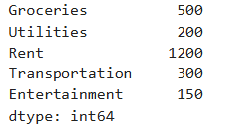

**Lab3: Suppose you want to track and analyze the monthly energy consumption in your home. You have recorded the monthly energy usage for electricity and gas over a year, and you want to represent this data using Pandas Series.**

**Input:**

**# Months in a year**

**months = ['January', 'February', 'March', 'April', 'May', 'June', 'July', 'August', 'September', 'October', 'November', 'December']**

**# Monthly energy consumption data (example data in kilowatt-hours for electricity and therms for gas)**

**electricity_usage = [350, 320, 310, 330, 340, 370, 380, 360, 350, 330, 320, 330] gas_usage = [20, 18, 16, 15, 12, 10, 8, 9, 12, 15, 17, 19]**

**Code:**

**import pandas as pd**

**# Input data**

**months = ['January', 'February', 'March', 'April', 'May', 'June', 'July', 'August',**

**'September', 'October', 'November', 'December']**

**electricity_usage = [350, 320, 310, 330, 340, 370, 380, 360, 350, 330, 320, 330]**

**gas_usage = [20, 18, 16, 15, 12, 10, 8, 9, 12, 15, 17, 19]**

**# Create Pandas Series for electricity and gas usage**

**electricity_series = pd.Series(data=electricity_usage, index=months)**

**gas_series = pd.Series(data=gas_usage, index=months)**

**# Output the Pandas Series**

**print("Electricity Usage (kWh):")**

**print(electricity_series)**

**print("\nGas Usage (therms):")**

**print(gas_series)**

**Output:**

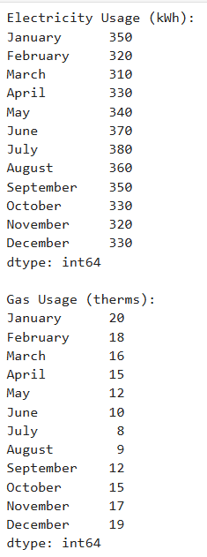

**Lab4:Suppose you are managing a website and want to analyze the monthly revenue generated from advertising. You have recorded the monthly revenue for the past year, and you want to represent this data using a Pandas Series. Input:**

**# Months in a year**

**months = ['January', 'February', 'March', 'April', 'May', 'June', 'July', 'August', 'September', 'October', 'November', 'December']**

**# Monthly advertising revenue data (example data in USD)**

**revenue = [5000, 5200, 4800, 5400, 5600, 5800, 6100, 5900, 6200, 6500, 7000, 6900]**

**Code:**

**import pandas as pd**

**# Input data**

**months = ['January', 'February', 'March', 'April', 'May', 'June', 'July', 'August',**

**'September', 'October', 'November', 'December']**

**revenue = [5000, 5200, 4800, 5400, 5600, 5800, 6100, 5900, 6200, 6500, 7000, 6900]**

**# Create a Pandas Series for revenue**

**revenue_series = pd.Series(data=revenue, index=months)**

**# Output the Pandas Series**

**print("Monthly Advertising Revenue (USD):")**

**print(revenue_series)**

**Output:**

